PROJECT REPORT
Metro Ticket Generating System in ServiceNow
A Digital Metro E-Ticketing Solution built on the ServiceNow Platform

Student ID:23NU1A4221
Submitted by: Konathala Venkata Satyalakshmi

Table of Contents

1.INTRODUCTION
1.1 Project Overview
1.2 Purpose
2.IDEATION PHASE
2.1 Problem Statement
2.2 Empathy Map Canvas
2.3 Brainstorming
3.REQUIREMENT ANALYSIS
3.1 Customer Journey Map
3.2 Solution Requirement
3.3 Data Flow Diagram
3.4 Technology Stack
4.PROJECT DESIGN
4.1 Problem Solution Fit
4.2 Proposed Solution
4.3 Solution Architecture
5.PROJECT PLANNING & SCHEDULING
5.1 Project Planning
6.FUNCTIONAL AND PERFORMANCE TESTING
6.1 Performance Testing
6.2 User Acceptance Testing (UAT)
7. RESULTS
7.1 Output Screenshots
8. ADVANTAGES & DISADVANTAGES
9. CONCLUSION
10. FUTURE SCOPE
11. APPENDIX
- Source Code (if any)
- Dataset Link
- GitHub & Project Demo Link

1. INTRODUCTION

1.1 Project Overview
The Metro Ticket Generating System is a digital ticketing solution designed to modernize and streamline the metro travel experience. Built entirely on the ServiceNow platform, it leverages the platform’s Service Catalog, Flow Designer, and automation capabilities to provide commuters with a seamless ticket booking process.
Passengers can book tickets online by selecting their source and destination stations, journey type (single or return), number of passengers, and preferred payment mode. The system automatically calculates the fare using Catalog Client Scripts and generates a QR-coded digital ticket that can be scanned at metro station gates for entry.
Beyond ticket issuance, the system ensures that every transaction is securely logged in ServiceNow tables, enabling administrators to monitor usage, track revenue, and analyze commuter trends. This digital-first approach reduces reliance on manual ticket counters, minimizes human error, and enhances the overall efficiency of metro operations.
The project demonstrates how low-code/no-code platforms like ServiceNow can be applied to real-world transportation challenges, offering scalability, security, and automation without extensive custom development.

1.2 Purpose
The primary purpose of this project is to digitize metro ticket booking and issuance through ServiceNow’s ecosystem of tools, thereby creating a faster, smarter, and more reliable commuter experience. Specifically, the system aims to:
- Enable convenience: Allow commuters to book tickets anytime, anywhere, without waiting in queues at physical counters.
- Ensure accuracy: Automate fare calculation using pre-defined station-to-station pricing logic, eliminating manual errors.
- Maintain transparency: Record every booking digitally in ServiceNow tables for auditing, reporting, and analytics.
- Improve efficiency: Reduce turnaround time for ticket issuance through automation, ensuring instant QR ticket generation.
- Enhance scalability: Provide a foundation that can be extended to support SMS/Email ticket delivery, mobile app integration, and payment gateway connectivity.
- Support sustainability: Reduce paper usage by replacing physical tickets with digital QR codes, contributing to eco-friendly operations.
By combining automation, accessibility, and security, the Metro Ticket Generating System not only addresses current commuter pain points but also lays the groundwork for future innovations in smart transportation systems.

2. IDEATION PHASE

2.1 Problem Statement
Commuters currently rely on manual, counter-based or physical ticketing systems for metro travel, which leads to long queues, delays, human errors in fare calculation, and inefficient use of station staff. There is no unified digital platform that allows passengers to book metro tickets instantly, calculate fares automatically, and receive a verifiable digital ticket without visiting a counter.
This lack of automation results in:
- Passenger inconvenience during peak hours.
- Operational inefficiency due to staff dependency.
- Revenue leakage from manual errors.
- Limited scalability for growing metro networks
2.2 Empathy Map Canvas
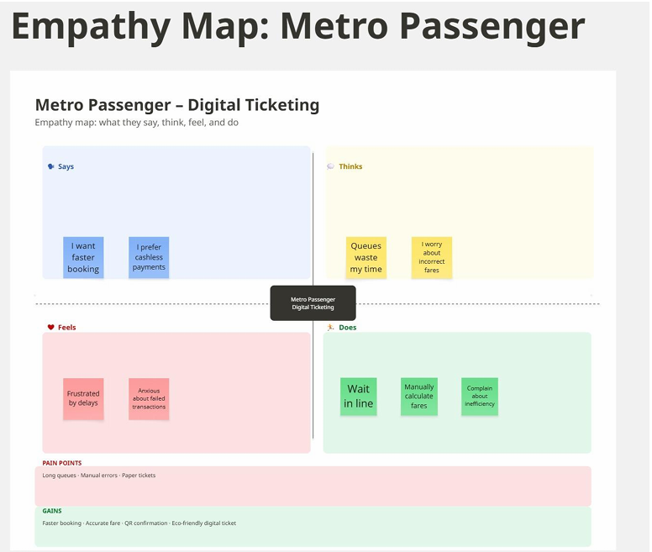

2.3 Brainstorming & Idea Prioritization

Brainstorming Overview
During the ideation phase, multiple ideas were generated to address passenger pain points such as long queues, manual fare errors, and reliance on paper tickets.

Key Ideas
- Service Catalog Ticket Booking
- Automated Fare Calculation
- QR Code Digital Ticket Generation
- Digital Payment Integration (UPI, cards)
- Admin Dashboard for monitoring and analytics
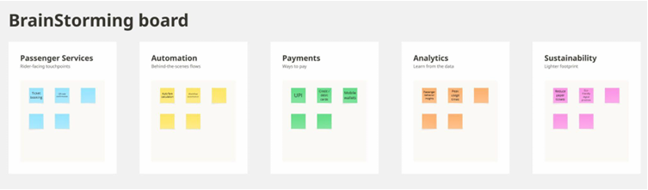

Reference https://miro.com/app/board/uXjVHnsmcmM=/?share_link_id=796824267924

Final Selected Ideas
Based on impact and feasibility, the following ideas were prioritized for implementation:
- Service Catalog Ticket Booking
- Automated Fare Calculation
- QR Code Digital Ticket Generation
- Digital Payment Support
- Admin Dashboard
Decision: The project focuses on simplifying ticket booking, automating fare calculation, generating QR tickets, and enabling digital payments. Advanced analytics and WhatsApp ticketing are considered future enhancements.

3.REQUIREMENT ANALYSIS

3.1 Customer Journey Map
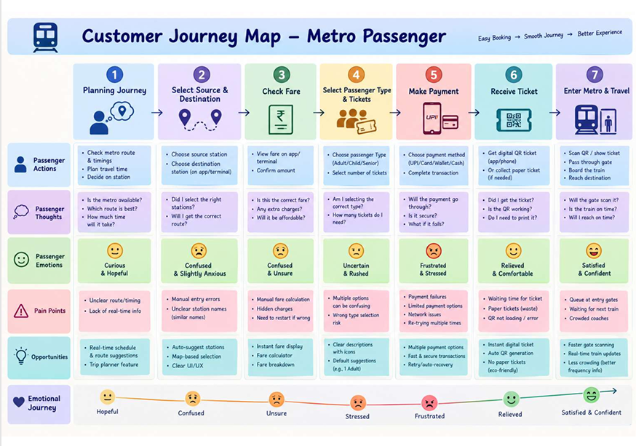
3.2 Solution Requirement

Software Requirements
- ServiceNow instance with Service Portal & Flow Designer enabled
- Email Notifications, Scheduled Jobs, Client Scripts, Business Rules support
- Modern web browser (Chrome, Edge, Firefox)
- QR Code API integration for ticket generation
- Access Control Lists (ACLs) for security

Hardware Requirements
- Standard desktop/laptop computer
- Minimum 4 GB RAM (8 GB recommended for smooth performance)
- Stable internet connection
- Smartphone (optional) for mobile ticket access
- Metro station gate scanners compatible with QR tickets

3.3 Data Flow Diagram
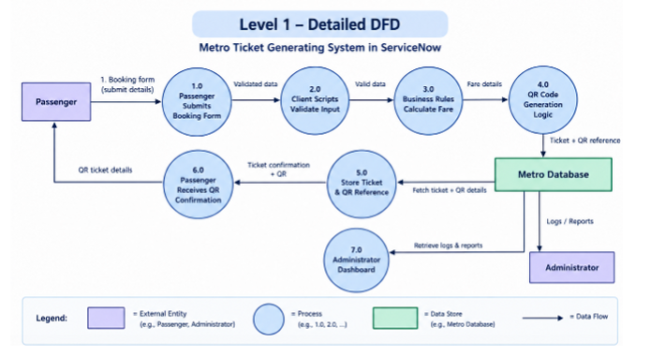

3.4 Technology Stack

Layer | Technologies Used
Presentation / UI Layer | ServiceNow Service Portal, Service Catalog, HTML, CSS, JavaScript
Application / Business Logic Layer | Catalog Client Scripts, UI Policies, Business Rules, Flow Designer, JavaScript
QR Code / Integration Layer | Service Portal Widget, QR Server API, ServiceNow Scripting
Data Layer | ServiceNow Platform Database, Custom Tables
Security Layer | ServiceNow ACLs, Roles, Authentication, HTTPS
Cloud / Infrastructure Layer | ServiceNow Cloud Platform

4.PROJECT DESIGN

4.1 Problem Solution Fit
The Metro Ticket Generating System addresses common problems faced by metro passengers, including long queues, manual ticket booking, fare calculation errors, and the inconvenience of handling physical tickets. The proposed ServiceNow-based solution digitizes the ticket booking process by allowing passengers to enter their source and destination, select passenger type and ticket quantity, calculate the fare automatically, and receive a digital QR-based ticket through the Service Portal.
The solution reduces manual effort and waiting time by automating ticket creation and fare calculation using ServiceNow Business Rules and Flow Designer. The QR-based digital ticket provides convenient and faster ticket verification at metro stations. Overall, the system aims to provide a simple, efficient, secure, and user-friendly ticketing experience while reducing common errors in the existing manual process.
4.2 Proposed Solution
The proposed solution is a ServiceNow-based Metro Ticket Generating System that digitizes and automates the metro ticket booking process. Passengers can enter their source and destination, select passenger type and number of tickets, and receive the calculated fare. The system processes the booking and generates a QR-based digital ticket that can be displayed through the Service Portal for verification.
S.No. | Parameter | Description
1 | Problem Statement | Metro passengers may face long queues, manual ticket booking, fare calculation errors, and inconvenience in managing physical tickets.
2 | Idea / Solution Description | A ServiceNow-based system that allows passengers to enter journey details, select passenger type and ticket quantity, calculate fares automatically, process bookings, and receive a QR-based digital ticket.
3 | Novelty / Uniqueness | Combines automated fare calculation, ticket processing, and QR-based digital ticket generation within a single ServiceNow platform.
4 | Social Impact / Customer Satisfaction | Reduces waiting time and manual effort while providing passengers with a convenient digital ticketing experience and faster verification.
5 | Business Model / Revenue Model | The project is primarily a prototype and does not directly generate revenue. In a real-world implementation, it could support metro ticket fare collection through digital ticket transactions.
6 | Scalability of the Solution | Can be extended to multiple stations, routes, passenger categories, and ticket types. Future enhancements can include payment gateway integration, travel history, notifications, smart-card recharge, and admin dashboards.
4.3 Solution Architecture

The solution architecture defines how the Metro Ticket Generating System components interact within the ServiceNow platform. The passenger accesses the system through the Service Portal and Service Catalog, where journey details are entered and validated. Catalog Client Scripts and UI Policies manage dynamic form behavior, while Business Rules and Flow Designer perform fare calculation and ticket processing. The system stores booking and ticket information in ServiceNow custom tables. A QR Server API is used to generate the QR code, which is displayed through a Service Portal widget as a digital ticket for verification.
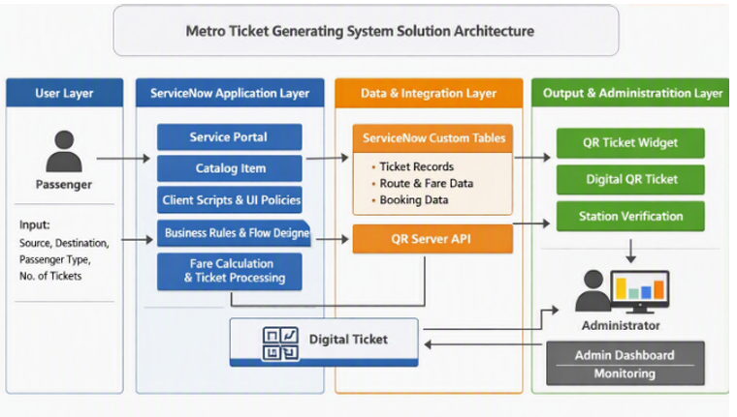
Figure: Solution Architecture of Metro Ticket Generating System

5.PROJECT PLANNING & SCHEDULING

5.1 Project Planning
Stakeholders: Passengers (end users), Station Managers, Metro Operations Team, IT Admins
Execution Phases (Completed):
Phase | Title | Key Activities | Status
1 | Requirement Analysis & Planning | Objectives, scope, stakeholder mapping, roadmap | ✅ Completed
2 | Backend Development | Custom tables, data architecture | ✅ Completed
3 | UI/UX Development | Service Catalog item, variables, UI Policies | ✅ Completed
4 | Testing & Security | Client Scripts, ACLs, data integrity checks | ✅ Completed
5 | Deployment & Documentation | Service Portal deployment, demo, final presentation | ✅ Completed
Execution Roadmap (Milestones):
Catalog Form Setup → Fare Logic Script → QR Code Integration → Station Details Mapping → UI Pages → UAT & Deployment
Sprint Approach :
- Sprint‑1: Service Portal access, booking form, validation, submission
- Sprint‑2: Fare processing, QR ticket generation, notifications, admin verification
Velocity & Burndown :
- Total Story Points: 43 (Sprint‑1: 19, Sprint‑2: 24)
- Team Velocity: ~21.5 points per sprint (≈3.58 points/day)
- Burndown Chart: All story points completed by Day‑6 in each sprint

6.FUNCTIONAL AND PERFORMANCE TESTING

6.1 Performance Testing
Test ID | Scenario | Result | Status
PT01 | Open Service Portal | Portal opened successfully | Pass
PT02 | Open Catalog Item | Catalog item opened | Pass
PT03 | Load Booking Form | Variables loaded correctly | Pass
PT04 | Select Stations | Stations selected successfully | Pass
PT05 | Fare Calculation | Fare calculated automatically | Pass
PT06 | Journey Type Change | Fare updated correctly | Pass
PT07 | Payment Mode Logic | Dependent field worked | Pass
PT08 | QR Generation | QR code generated | Pass
PT09 | Submit Booking | Request created | Pass
PT10 | Request Processing | Booking details displayed | Pass
Observation: All performance scenarios passed; no issues observed.

6.2 User Acceptance Testing (UAT)
UAT ID | Scenario | Result | Status
UAT01 | Access booking service | Catalog item opened | Pass
UAT02 | Select stations | Stations selected | Pass
UAT03 | Select journey type | Single/Return worked | Pass
UAT04 | Enter passenger count | Passenger count accepted | Pass
UAT05 | Select payment mode | Payment mode logic worked | Pass
UAT06 | Fare calculation | Fare calculated automatically | Pass
UAT07 | QR generation | QR code displayed | Pass
UAT08 | Submit booking | Request created | Pass
UAT09 | View request | Booking details displayed | Pass
All UAT scenarios passed; acceptance criteria met. The system is validated and considered acceptable.

7. RESULTS
7.1 Output Screenshots

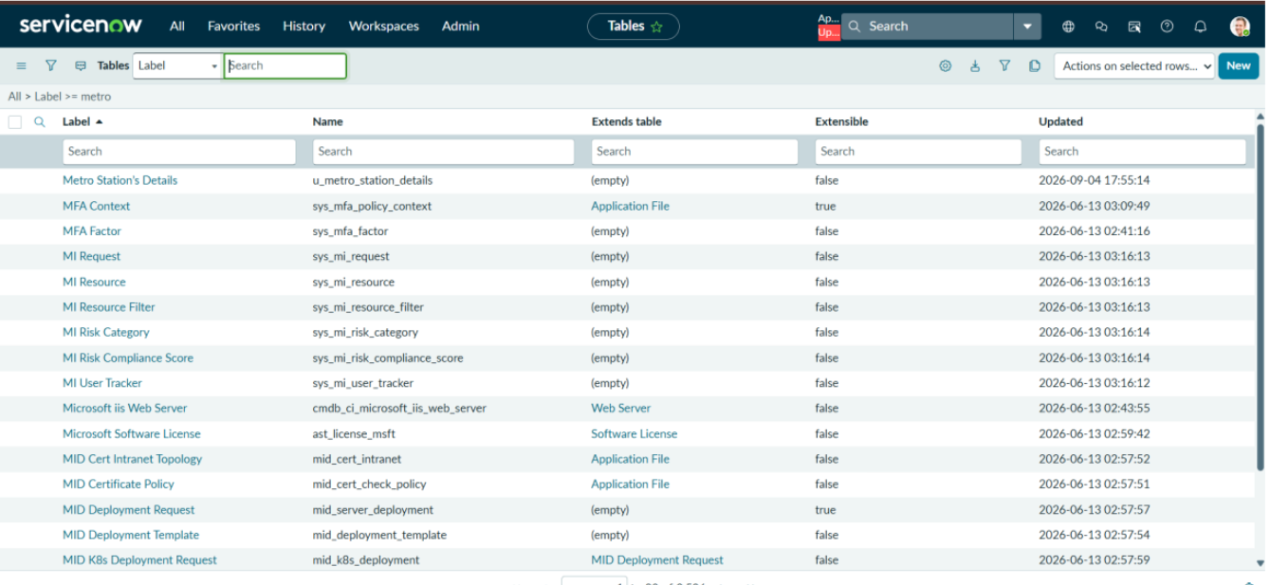
Figure 7.1: Custom tables list showing Metro Station’s Details table.

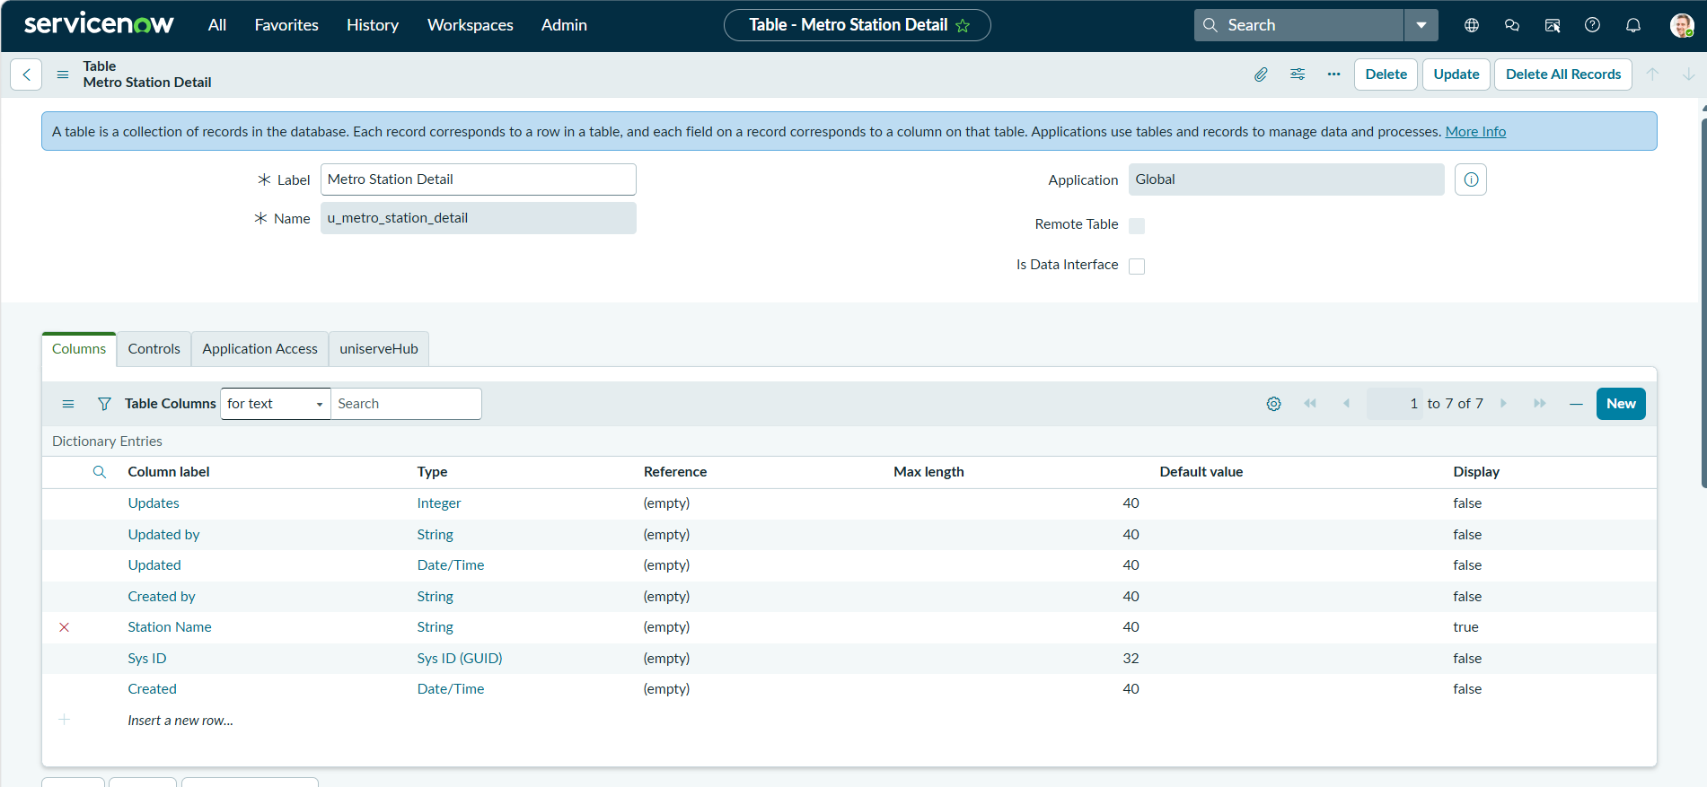
Figure 7.2: Table configuration for Metro Station’s Details with fields and metadata.

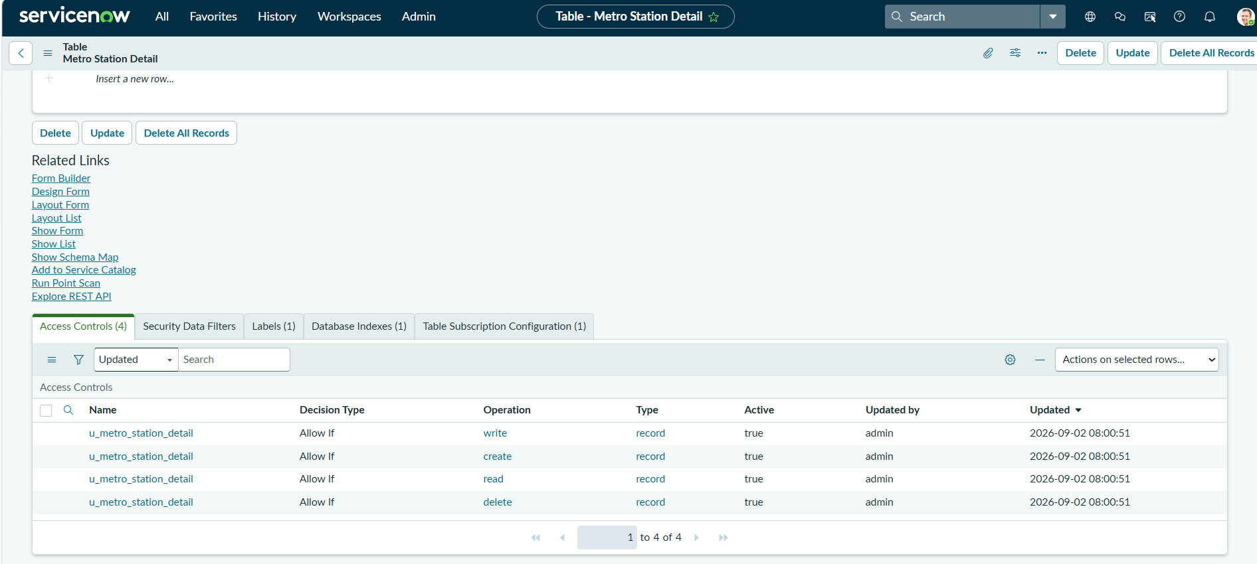
Figure 7.3: Access Controls on Metro Station’s Details table for CRUD operations.

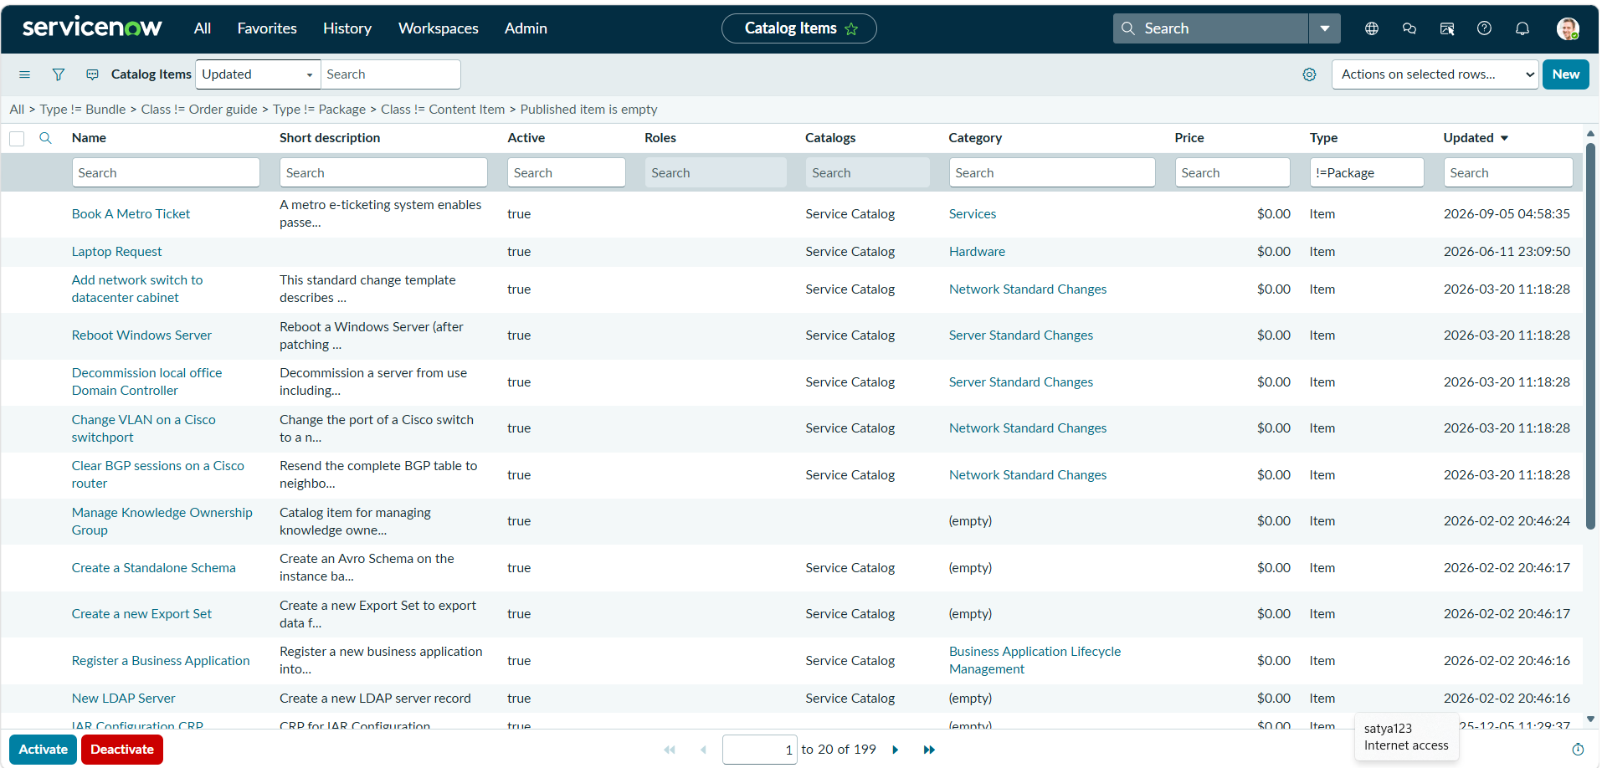
Figure 7.4: Catalog Items list showing Book A Metro Ticket under Services.
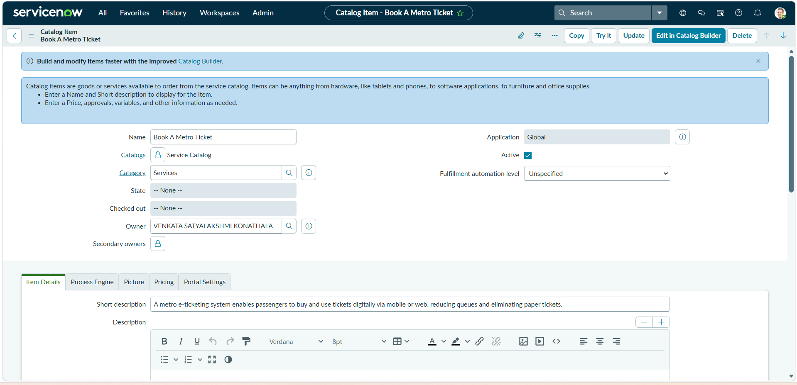
Figure 7.5: Book A Metro Ticket catalog item configuration with name, category, and description .

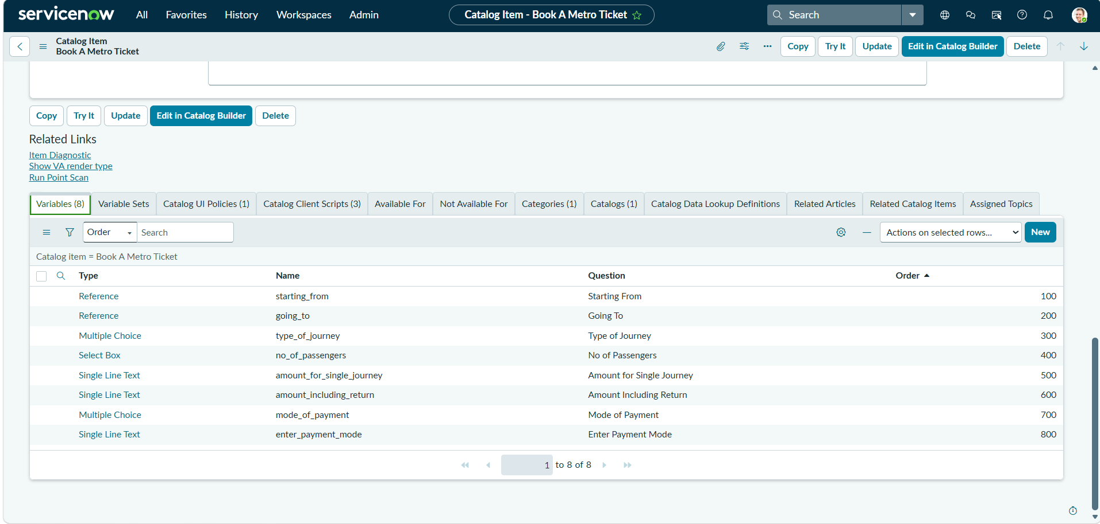
Figure 7.6: Book A Metro Ticket catalog item showing variable configuration.

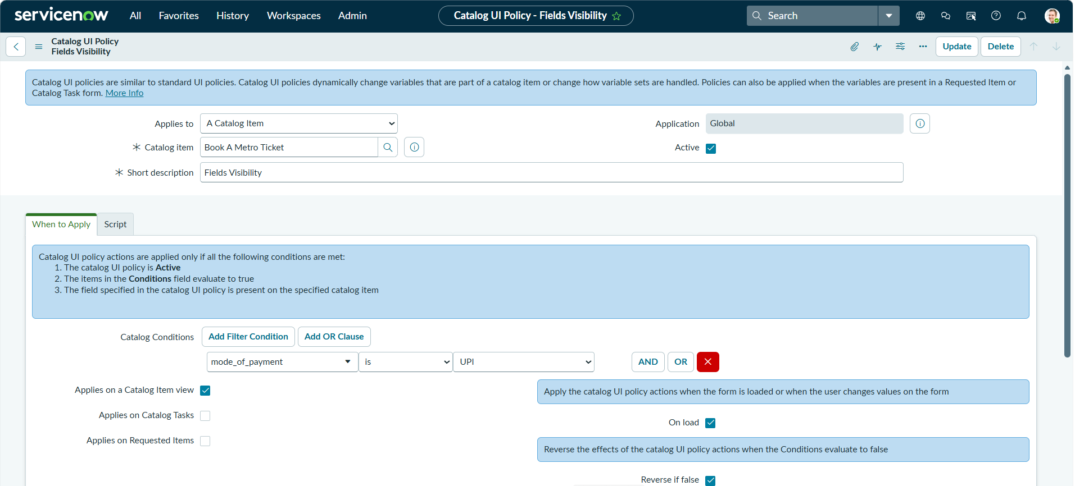
Figure 7.7: Catalog UI Policy making Enter Payment Mode visible when Mode of Payment is Others.

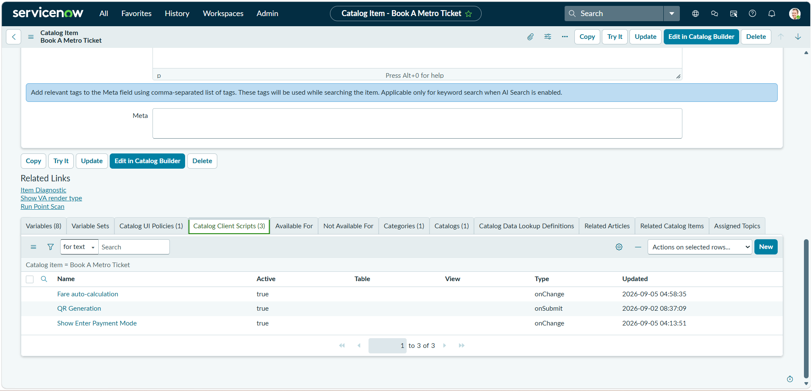
Figure 7.8: Catalog Client Scripts for Book A Metro Ticket with fare, QR, and payment logic.

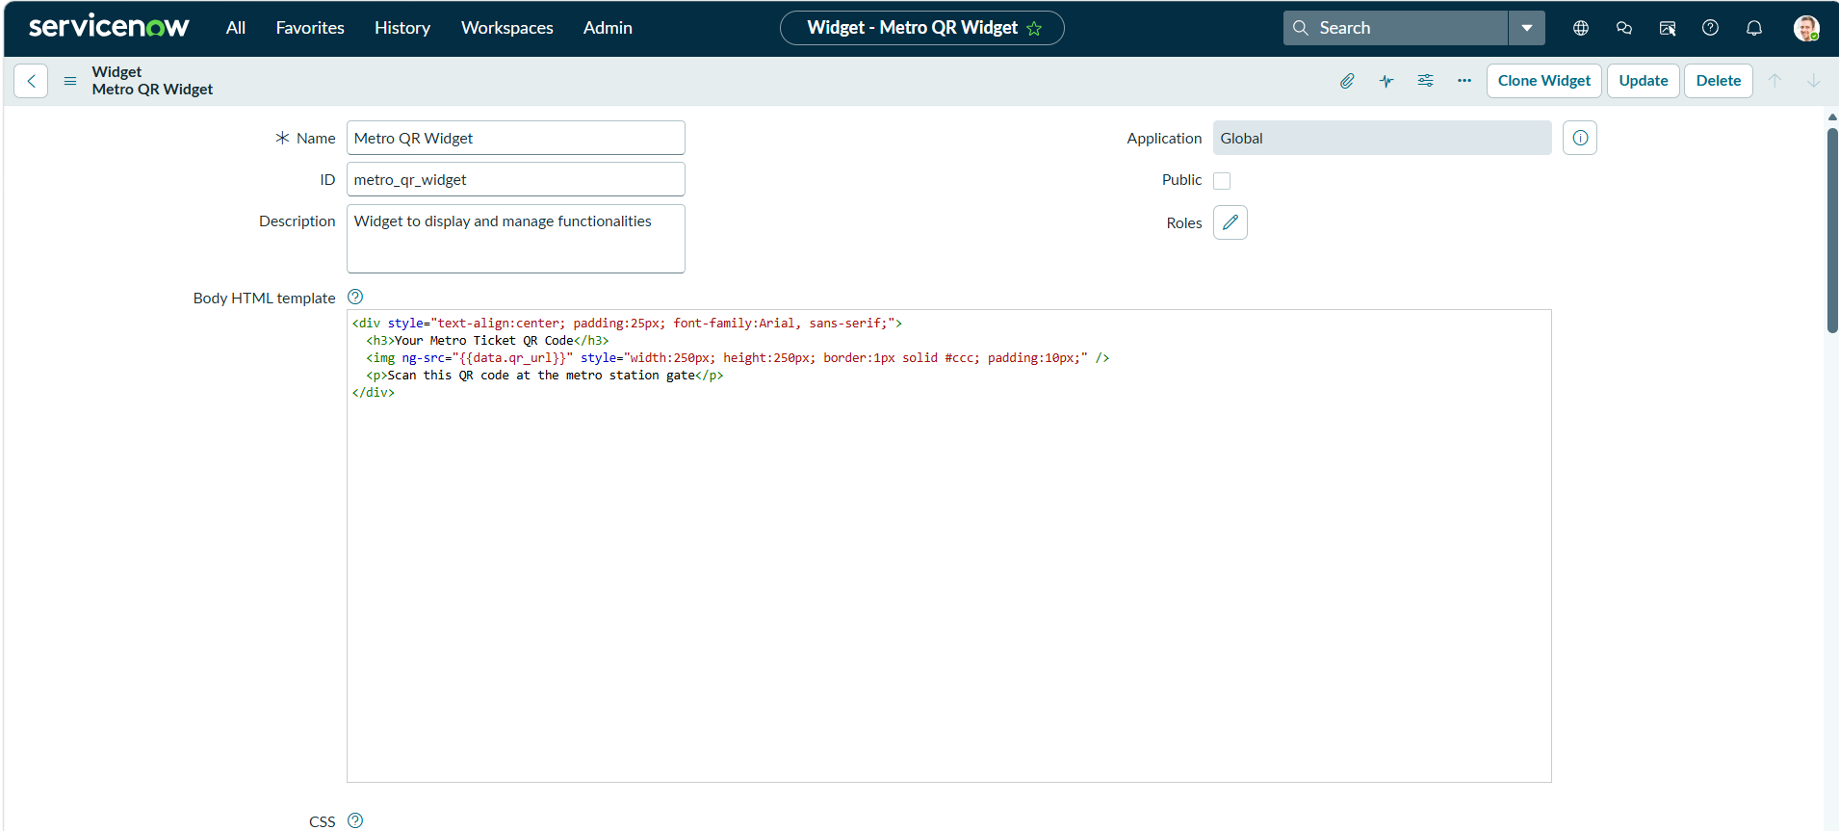
Figure 7.9: Metro QR Widget configuration for displaying passenger QR tickets.

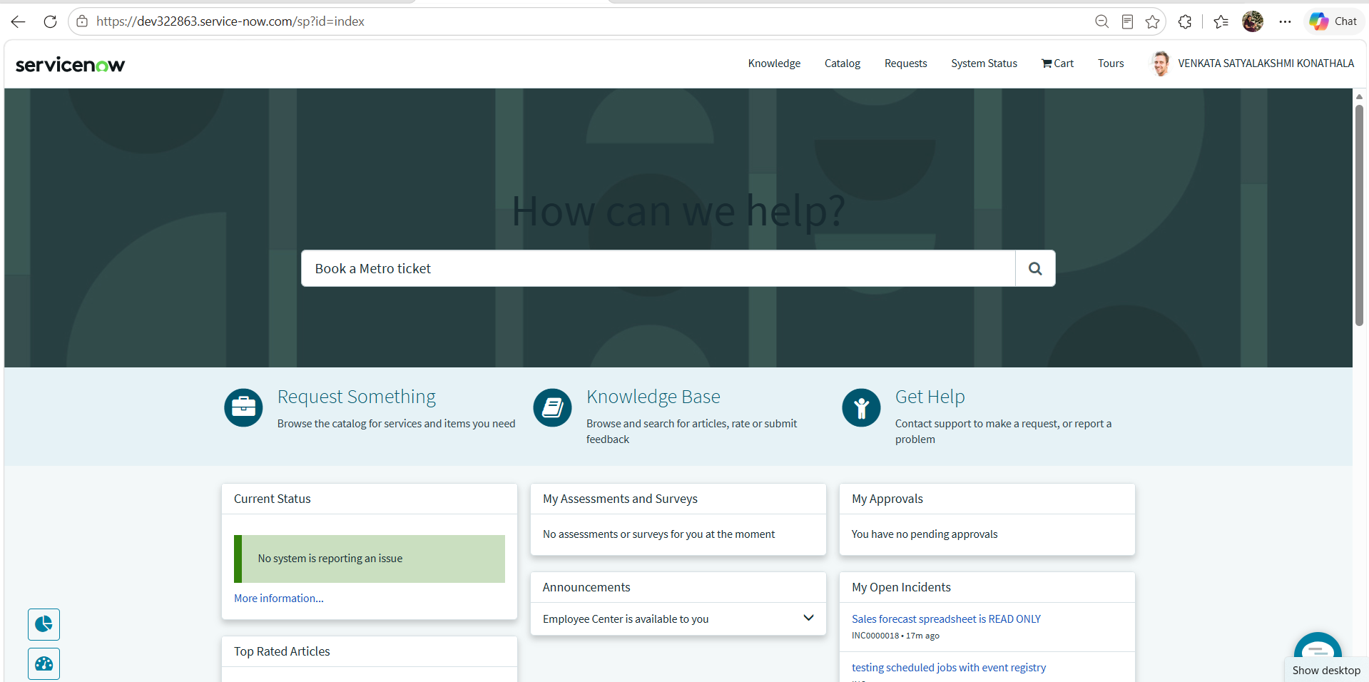
Figure 7.10: Service Portal Home Page with passenger searching Book A Metro Ticket.
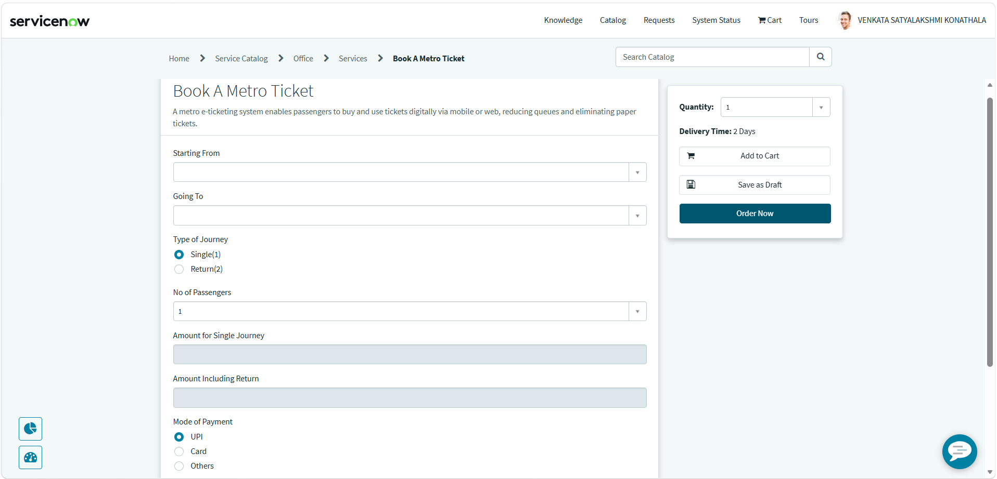
Figure 7.11: Book A Metro Ticket form with journey, passenger, fare, and payment fields.
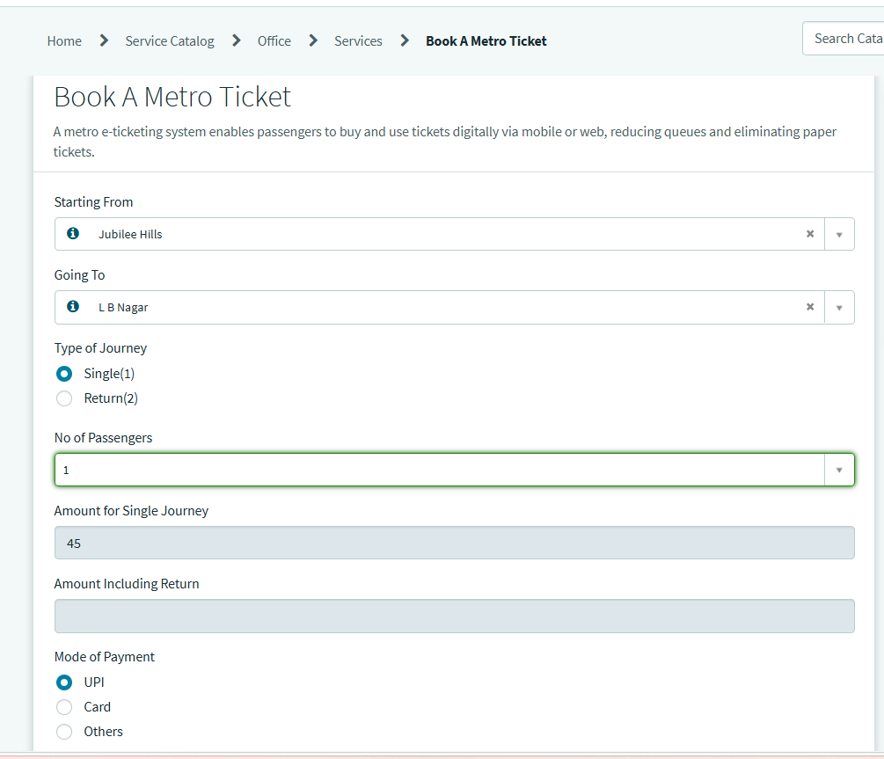
Figure 7.12: Booking form with filled journey, passenger, fare auto‑calculation, and payment details.

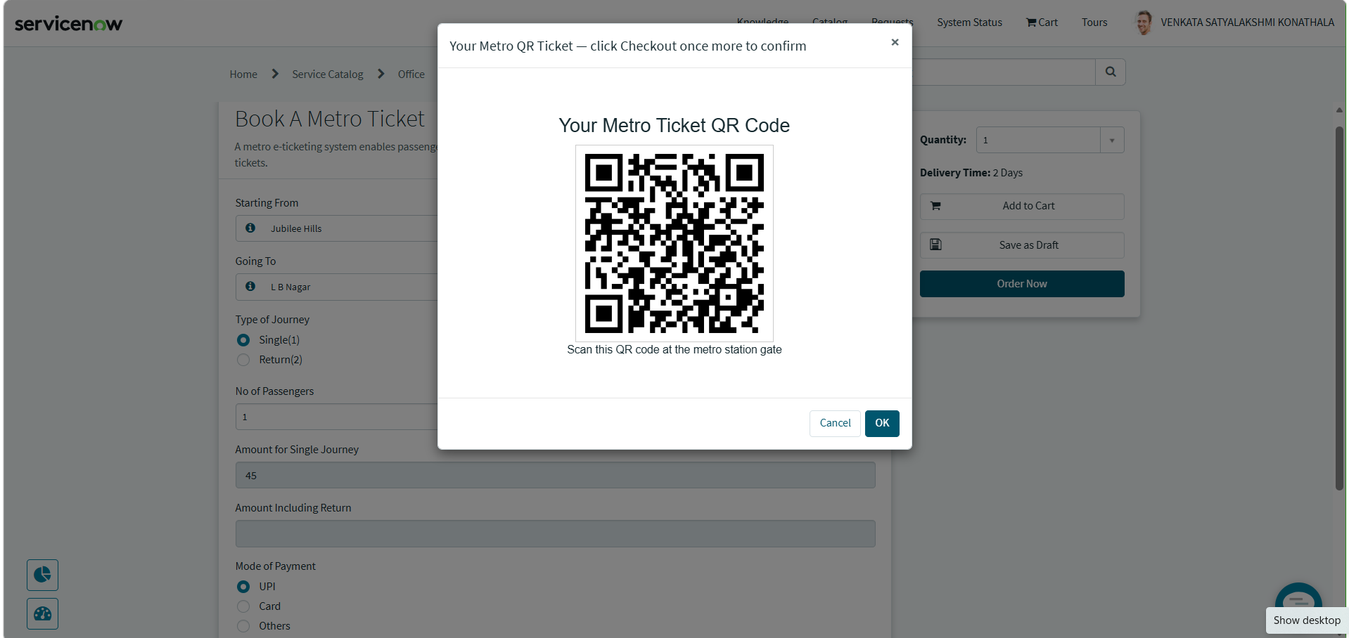Figure 7.13: QR Ticket confirmation modal displaying generated metro ticket code after Order Now.

8. ADVANTAGES & DISADVANTAGES

Advantages
- Provides faster and streamlined ticket booking through the Service Portal.
- Eliminates long queues at metro stations.
- Automated fare calculation reduces human errors.
- QR‑based digital tickets promote eco‑friendly, paperless operations.
- Supports multiple payment modes (UPI, Card, Others).
- Enhances passenger convenience with a user‑friendly interface.
- Reduces manual effort for station staff and improves efficiency.
- Ensures transparency in fare calculation and ticket generation.
- Secure ticketing with role‑based ACLs and encrypted transactions.
- Real‑time QR verification improves reliability at station gates.
- Admin dashboard enables monitoring, analytics, and error tracking.
- Scalable solution that can be extended to multiple stations and cities.
- Encourages digital adoption and modernization of metro services.
- Reduces operational costs by minimizing paper and manual processes.
- Improves overall passenger satisfaction and trust in metro services

Disadvantages
- Requires stable internet connection for booking and verification.
- Initial setup and configuration effort is needed.
- Dependency on QR scanners at metro stations.
- Limited offline support if the system is down.
- Basic training required for staff and administrators.

9.CONCLUSION
- The Metro Ticket Generating System successfully automates ticket booking using ServiceNow.
- Manual counter‑based processes are replaced with a digital, self‑service portal.
- Automated fare calculation, QR‑based ticket generation, and secure payment integration improve efficiency.
- The system reduces passenger waiting time, minimizes human error, and enhances commuter satisfaction.
- Overall, the project demonstrates how low‑code/no‑code platforms like ServiceNow can deliver scalable, real‑world solutions.

10.FUTURE SCOPE
- Integration with real payment gateways for live transactions.
- SMS/Email ticket delivery for broader accessibility.
- Mobile app extension for on‑the‑go ticket booking.
- Advanced analytics dashboard for passenger flow and revenue insights.
- Support for smart‑card recharge and travel history tracking.
- Multi‑language support for diverse commuter groups.
- Expansion to other transport systems (bus, rail) using the same framework.

11. APPENDIX
Source Code
Source Code 11.1: Fare Auto‑Calculation Script (onChange)
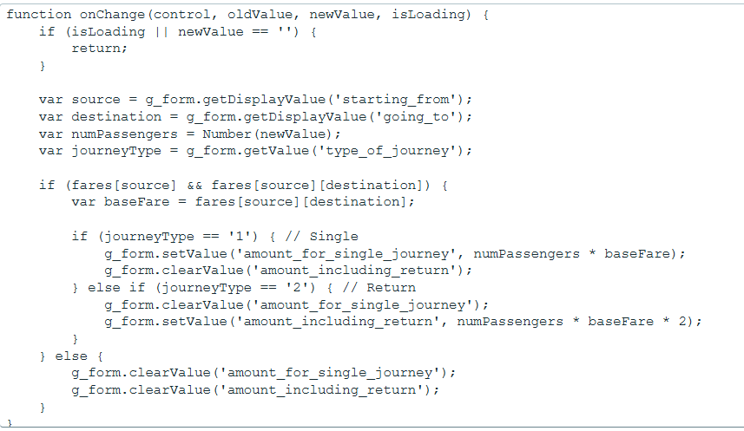
This script calculates the fare automatically based on source, destination, journey type, and passenger count
Source Code 11.2: QR Ticket Generation Script (onSubmit)
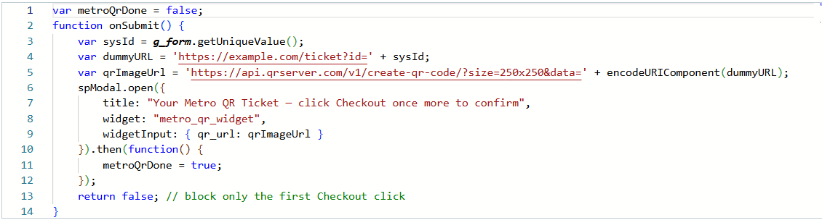
This script generates a QR code for the metro ticket and displays it in a confirmation modal.

Dataset Link
Not applicable - the project uses ServiceNow custom tables (u_metro_station_details) populated directly within the instance rather than an external dataset.

GitHub & Project Demo Link
GitHub Repository: kvenkatasatyalakshmi/MetroTicket-GeneratingSystem-ServiceNow: Digital Metro E‑Ticketing Solution built on ServiceNow
Project Demo Video: https://drive.google.com/file/d/1m7_4yqv3XcqR3sTO5VqoYIt7VAd9oIj2/view?usp=sharing

